Name: **ZOHAIB HASSAN SOOMRO**

RollNo#: **19SW42**

Subject: **DBS**



Table Creation:

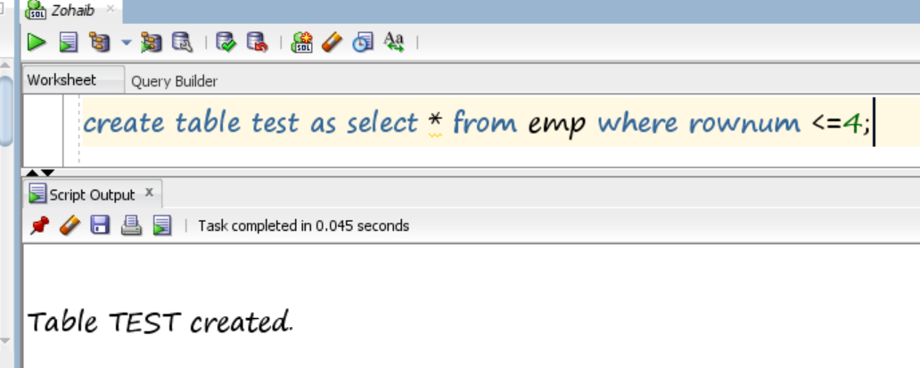

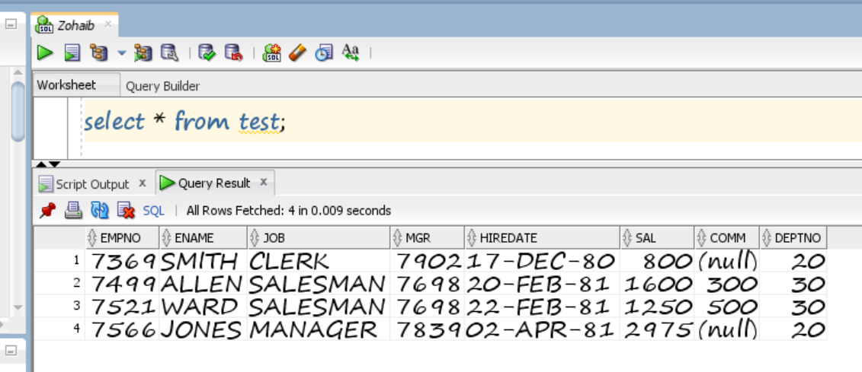

1. Create two different forms of the INSERT command to add two different employees with an ID of 65798(and 65799) and name Andrew Lopez(Drew More) to the emp table.

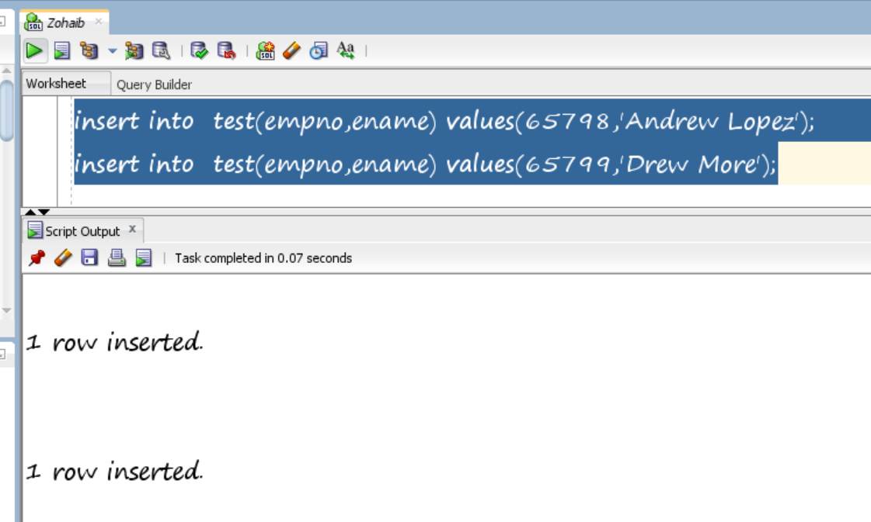

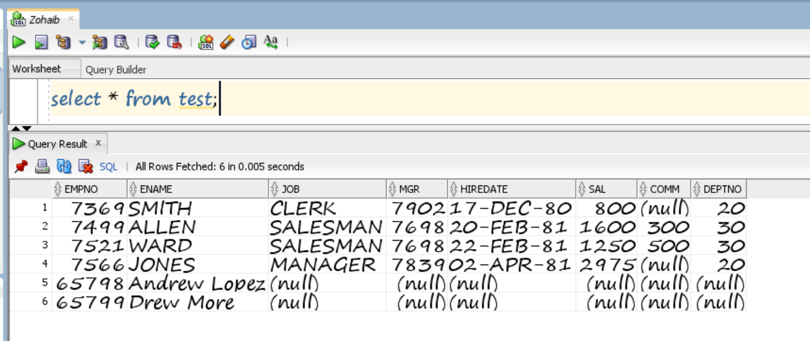

1. Update the data of any two columns of newly created row.

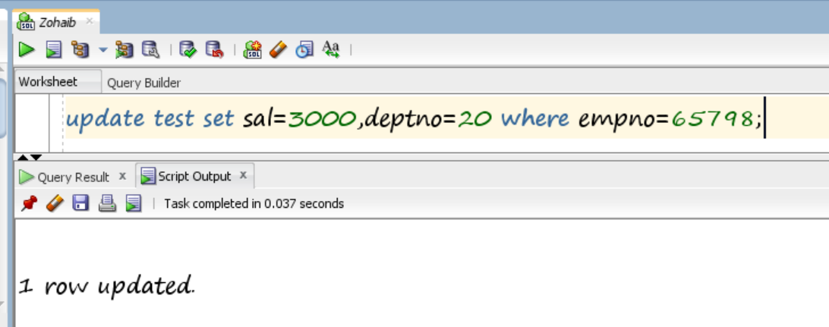

1. Write a query to delete that newly created row.

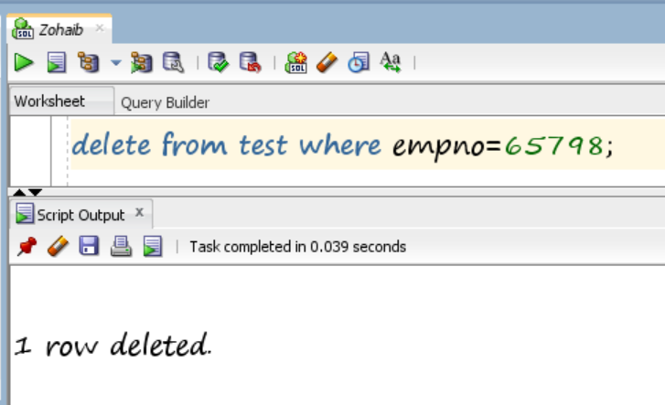

1. Create 3 save points and show how it works along with commit and rollbacks.

**Original Table:**

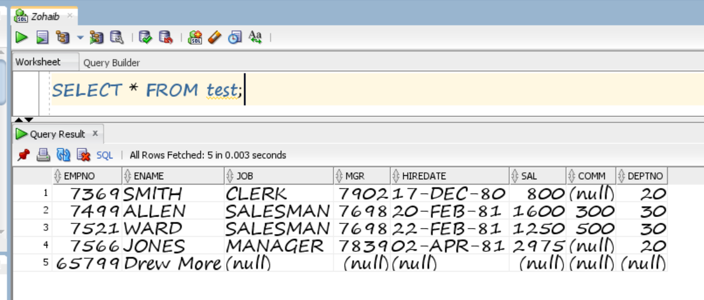

1. **Committing:**

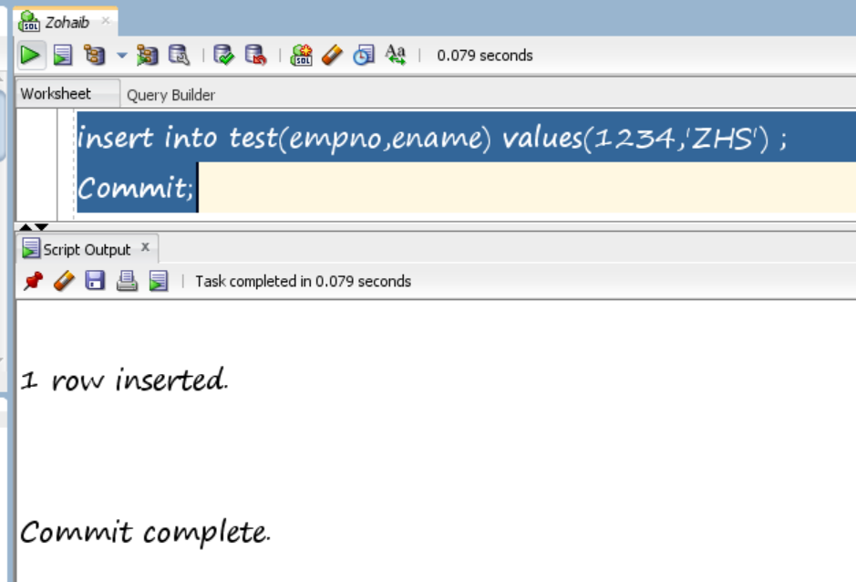

1. 1st Savepoint:

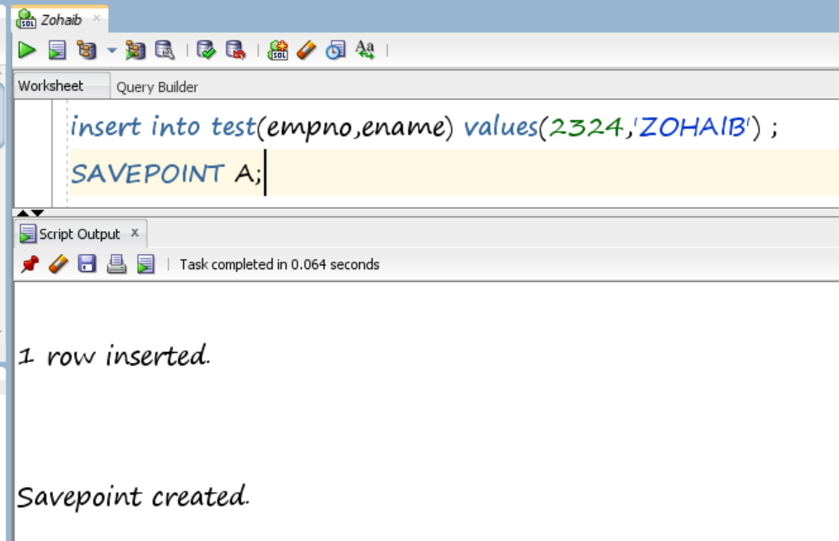

1. 2nd savepoint:

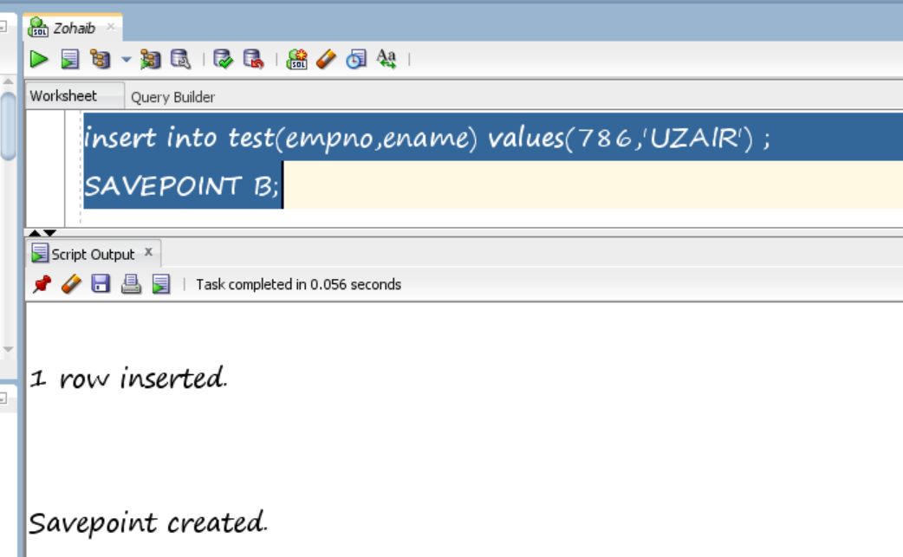

1. 3rd savepoint:

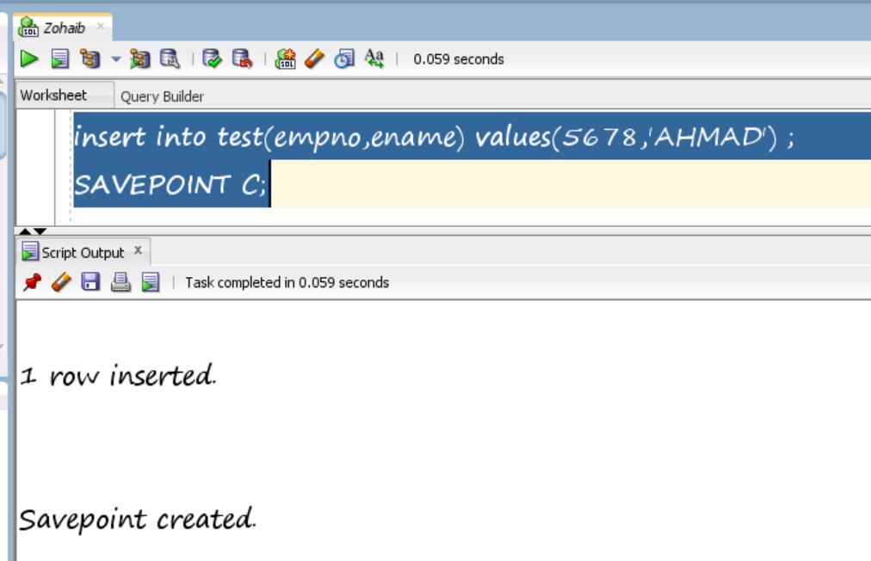

1. Selecting All from table now:

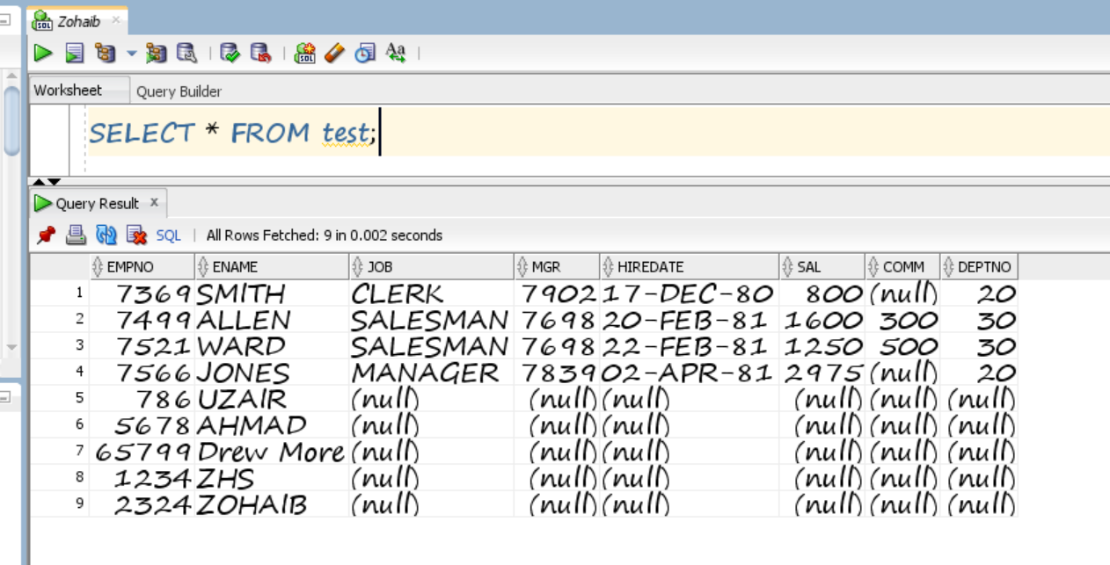

1. Rollbacking to 2nd Savepoint:

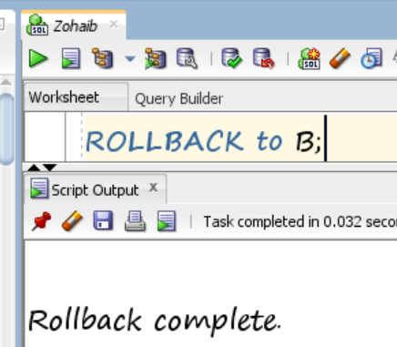

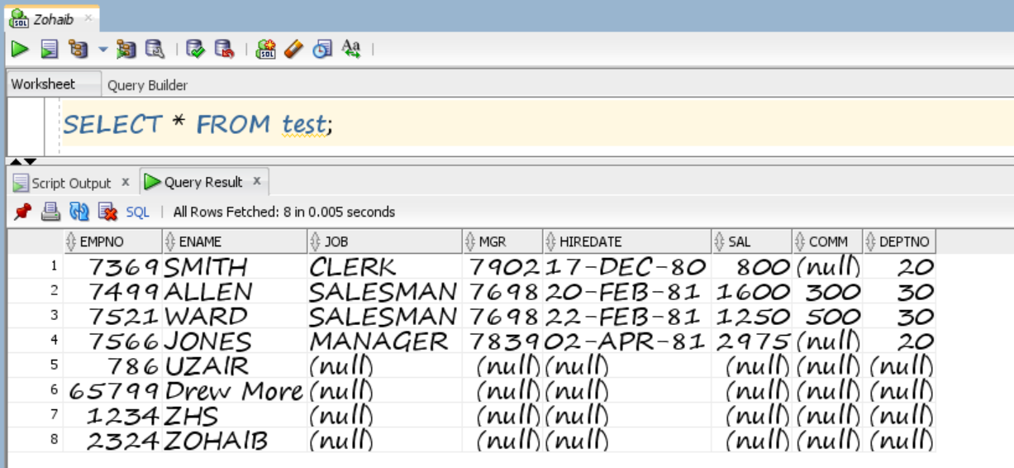

1. Rollbacking to last commit:

